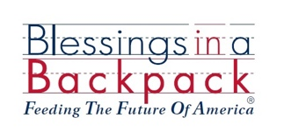

Blessings in a Backpack Parent Survey

Dear Parent/Guardian,

We want to thank you for being a part of Blessings in a Backpack Program. We would love to hear more about what you and your child think of the program. Your responses will help us improve the program to better serve the needs of your family.

Blessings in a Backpack…… | Agree | Not Sure | Disagree | Additional Comments
Is easy to participate in
Helps my child eat more nutritious food
Helps our family food budget
Gives my child food to be shared with the family
Has improved my child’s energy levels
Has improved my child’s overall behavior

- What were your three favorite foods provided in the bags?

- What were your least favorite foods provided in the bags?

- On a scale of 1-5, how much do you like this program?
- 1 (Do not like it)
- 2
- 3
- 4
- 5 (Love it)

- Please share your success story on how the program has impacted your family?

- Additional comments or suggestions for the program?

Thank you for your participation!

PLEASE RETURN COMPELTED SURVEY TO YOUR CHILD’S TEACHER
http://blessingsinabackpack.org

