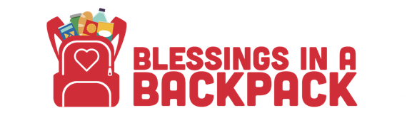

Blessings in a Backpack Parent Survey

Dear Parent/Guardian,

We want to thank you for being a part of Blessings in a Backpack Program. We would love to hear more about what you and your child think of the program. All of your responses will help to improve the program to better fit the needs of you and your child.

Blessings in a Backpack…… | Agree | Not Sure | Disagree | Additional Comments
Is easy to participate in
Helps my child eat more nutritious food
Helps our family food budget
Gives my child good to be shared with the family
Has improved my child’s energy levels
Has improved my child’s overall behavior

- What were your three favorite foods provided in the bags?

- What were your least favorite foods provided in the bags?

- On a scale of 1-5, how much do you like this program?
- 1 (Do not like it)
- 2
- 3
- 4
- 5 (Love it)

- Additional comments or suggestions for the program?
Thank you for your participation!

