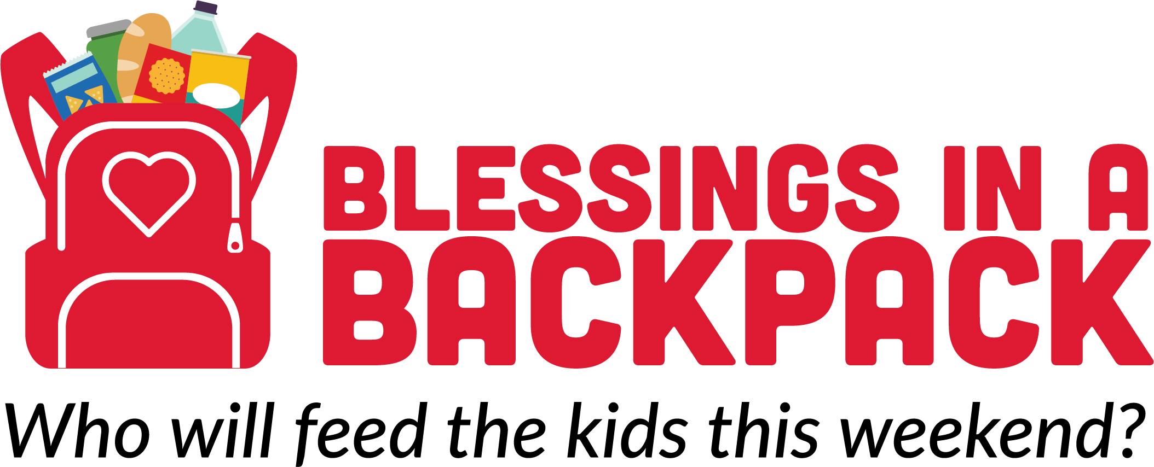

Board Chair
Richard Stephens

Vice Chair
Richard Gordon

Treasurer
Teresa McMahon

Secretary
Joe DePippo

Board Members
Junior Bridgeman
Paul Colangelo
Tonya York Dees
Ana Dutra
Michael Gouloff
Darby Hills
Ubong Ituen
Doug Meijer
Sara Moores
Kate Rose
Cynthia A. Ryan
Reena Sood
Ramona Ustian

Chief Executive Officer
Brooke Wiseman

National Headquarters
4121 Shelbyville Rd.
Louisville, KY 40207
P: 800-872-4366

Chicago Office
135 S. LaSalle St., Ste. 1921
Chicago, IL 60603
P. 312-366-2760

Blessingsinabackpack.org

DATE

Name
Organization Name
Address Line 1
Address Line 2
City, State Zip

Dear Blank,

Most people can’t wait for the weekend. For the 13 million food insecure kids across America, can’t wait for it to be over.

During the school week, one in five students are provided with the nourishment they need from their school’s free and reduced-price meal program, but what happens when school closes its doors on Friday for the weekend? The consequences are much more than a growling stomach. Hunger can cause many physical health problems. It can also shorten a child’s attention span, lower their IQ, and keep them from making good grades.

Incorporated in 2008 with a goal of providing weekend nutrition to hungry children, Blessings in a Backpack (Blessings) has grown into the only national organization solely dedicated to closing the weekend hunger gap for food insecure students. During the 2017-2018 school year, Blessings provided more than 3 million hunger-free weekends for more than 87,000 kids nationwide. With a bag of food in their backpacks as they left school on Friday, these kids had food to fill the 65-hour weekend nutrition gap.

In April 2017, Blessings was awarded Charity Navigator’s four-star rating, the highest score possible, due to Blessings’ financial health, accountability, and transparency. In addition to being awarded Charity Navigator’s highest ranking, Blessings is now a GuideStar Platinum organization, the highest level of recognition offered.

Blessings welcomes the opportunity to discuss continuing our partnership together to create more hunger-free weekends a reality for students in need. Please contact me at phone number or email.

Sincerely,

Name
Title


