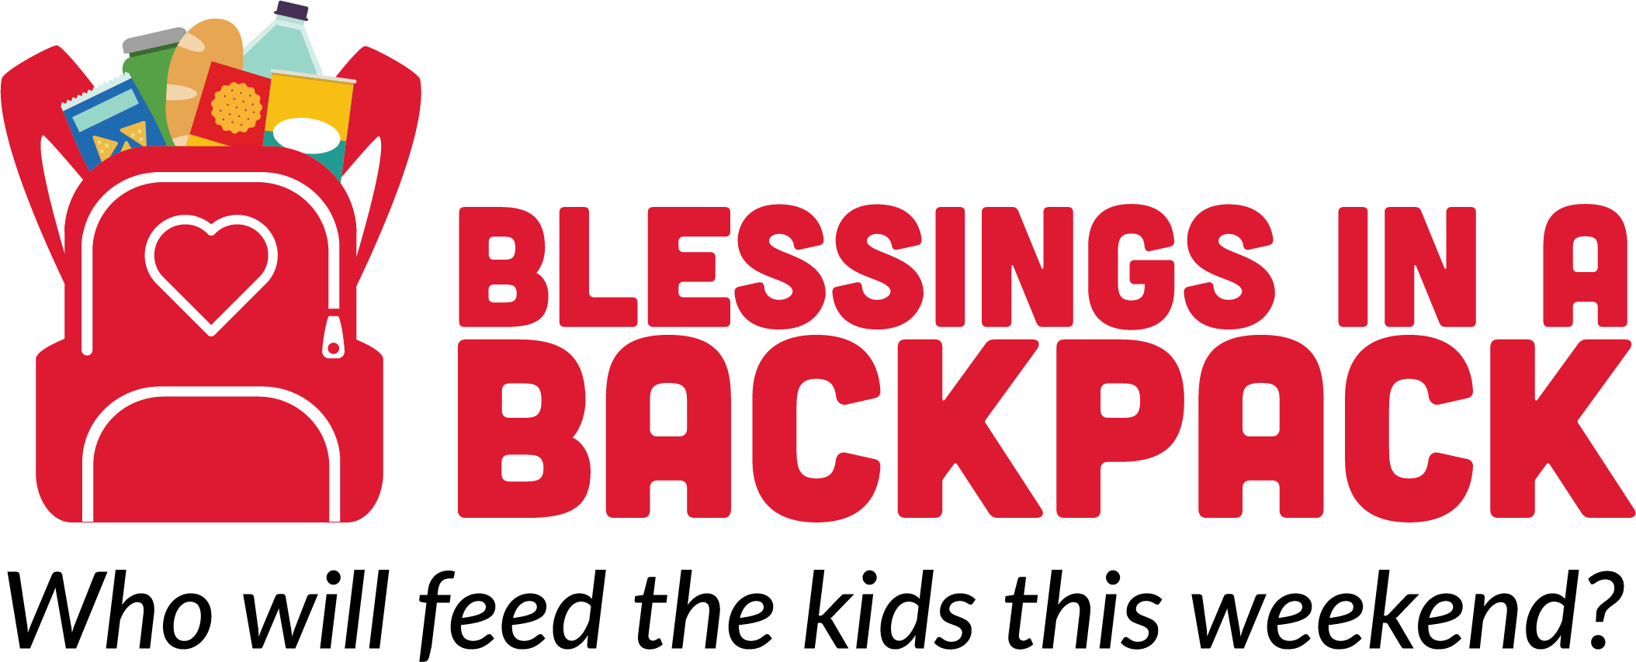

Date

Name
Address 1
Address 2
City, State Zip

Dear Name,

Thank you very much for your generous donation of $XXX on MM/DD/YYYY to help provide hunger-free weekends to kids living with food insecurity across the United States/in your school or region.

For one in five children, weekends mean 65 long hours of hunger. Your gift is an investment to ensure children receive the nutrition they need to grow, learn, and thrive—to be a kid. Thank you for partnering with us to end childhood hunger. You have made a difference.
Together, we are making hunger-free weekends a reality for children who are living with food insecurity. If you have any questions about Blessings in a Backpack, please contact us at XXX.XXX.XXXX or EMAIL.

With gratitude,

Name
Title

