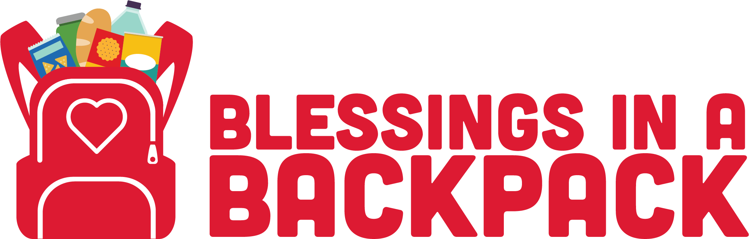

Parent Opt-In Letter

Dear Parent,

Your child is eligible to be a recipient of the Blessings in a Backpack program at SCHOOL NAME. The program is designed to provide non-perishable food every Friday to children that would benefit from supplemental nourishment over the weekend. The program runs the full 38-week school year and there is no cost to participate. If you wish for your child to participate in the program, please sign below. Once the program is implemented, your child will receive a bag of non-perishable food every Friday which will be distributed in a discreet and caring manner.

Thank you!

Signature
I want my child to participate in the Blessings in a Backpack program.

For additional information regarding this program please visit the Blessings in a Backpack website http://blessingsinabackpack.org/

(Spanish version available in PC Toolkit)

