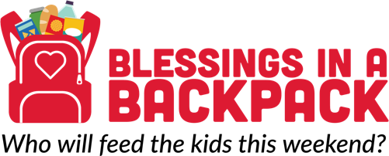

[Month] [Day], [Year]

[Name]
[Address]
[City], [State] [Zip]

Dear [Salutation],

Thank you for your [past support/interest in giving] to Blessings in a Backpack. Your partnership helped our volunteer teams provide XXXX hunger-free weekends to kids in [city or region name] the 2017-18 school year! Together, we are helping address the 65-hour weekend nutrition gap.

The 2018-19 school year marks the 10th birthday of Blessings in a Backpack—and we’re excited! In our first 10 years, we have experienced remarkable growth.

Since becoming a 501(c)(3) in 2008, Blessings has helped make more than 20 million hunger-free weekends possible. But, we are just getting started. As we enter the next decade, we have an excellent opportunity to make an even more significant impact on the weekend nutrition gap for children.

By further educating the public about the weekend nutrition gap and ways they can help, we can increase our capacity at [Program Name].

[Salutation], will you consider making a monthly gift of [gift amount] in celebration of our 10th birthday to help Blessings in Backpack lay the foundation for the next 10 years in [city or region name]?

If you have any questions about your past support or our plans for the future, please contact [Contact Name] at [EMAIL] or [PHONE NUMBER].

Sincerely,

