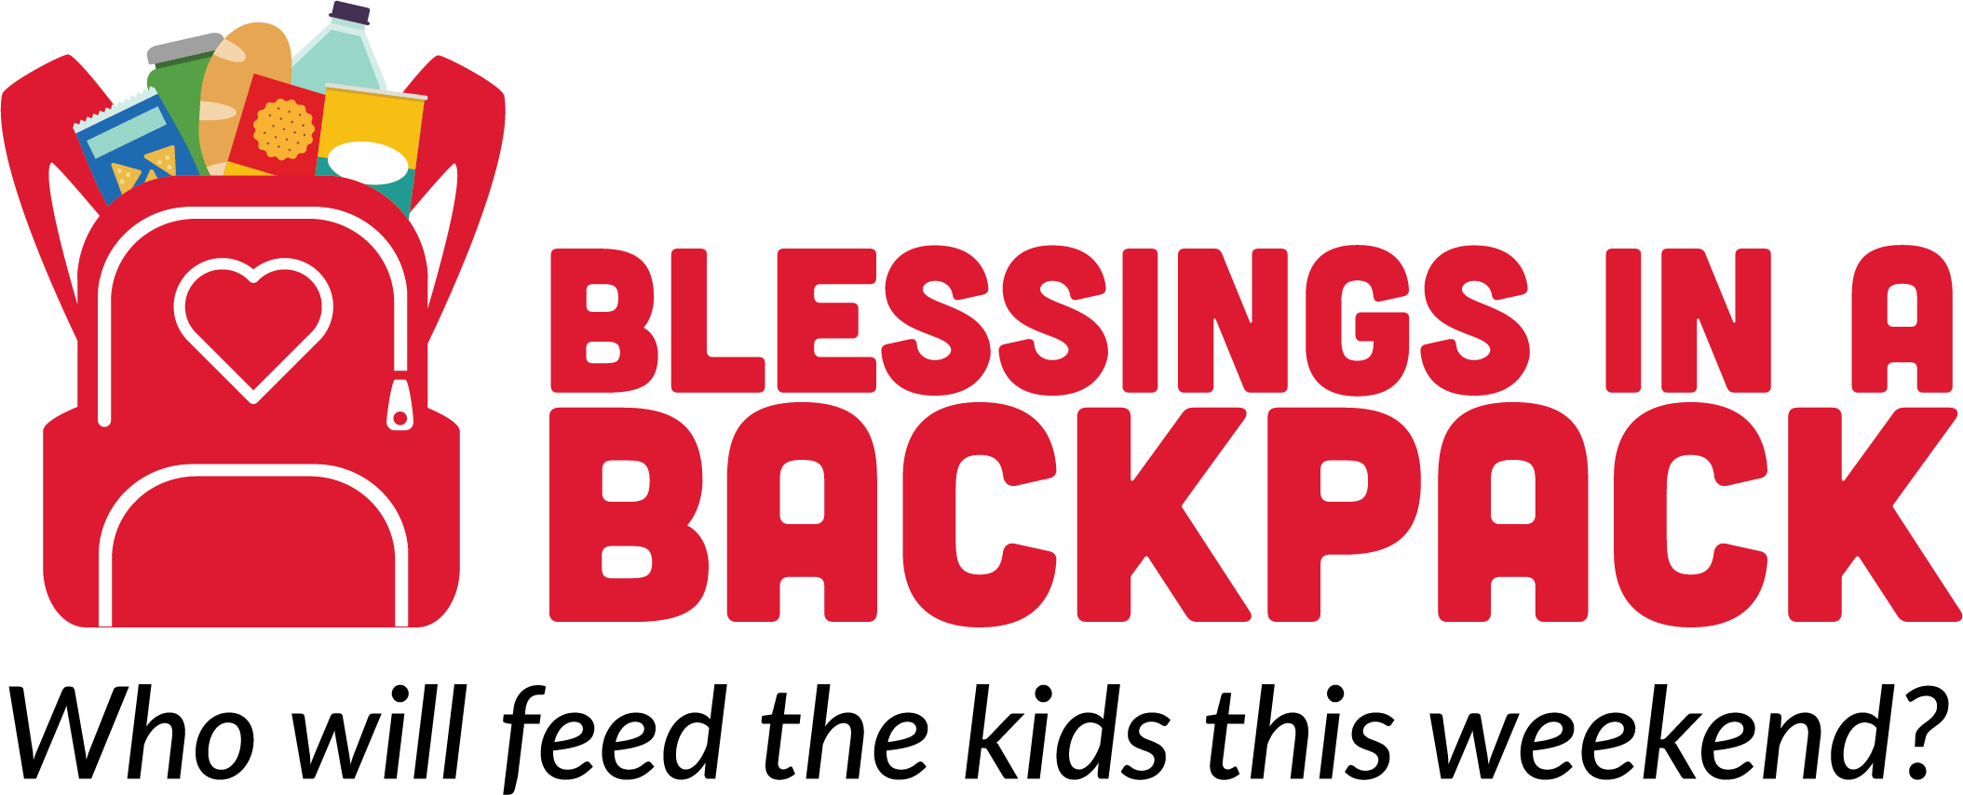
Strategic Plan Summary
Fiscal Years 2019 – 2021

Becoming a recognized leader in the fight against childhood hunger through feeding children on the weekend is our bold goal for the next ten years. For Blessings in a Backpack to achieve its bold goal, we must now take the next three years, Fiscal Years 2019 through 2021, to build a sustainable and scalable business model.

Blessings in a Backpack is at a crucial point where we need to identify alternatives to compliment the traditional grassroots model to support future growth. Blessings in a Backpack will search for and adapt sustainable solutions that provide a solid infrastructure for the longevity of Blessings in a Backpack. Over the next three years, Blessings in a Backpack will be measuring progress toward the following objectives.

WHAT WE STRIVE TO DO:
- Link knowledge to action to educate the public on this epidemic that effects over 13 million children in the United States
- Draw on the expertise, ingenuity, passion and pioneering spirit of volunteers across the country
- Ensure the sustainability of current programs
- Reach saturation in targeted geographies
- Increase the number of children served across the US
- Maintain low-cost options for nutritious foods

BY 2021, BLESSINGS IN A BACKPACK WILL HAVE:
- Established growth/scalability strategy
- Increased funding streams and diversity within them
- Established efficient procedures and processing, including food purchasing and distribution
- Strengthened reputation and increased brand awareness
- Invested in the tools needed to support human capital and technology
- Increased the number of children served by at least 10%

Blessings in a Backpack’s detailed yearly work plans incorporate critical action items to achieve successful outcomes that support the goal of delivering a sustainable and scalable business model. This plan is structured to support change by providing a lasting infrastructure. Six areas of focus emerged as crucial to advance Blessings in a Backpack: Growth, Fiscal Responsibility, Food Purchasing and Distribution Solutions, Brand Awareness, Human Capital, and Technology. All are essential and interlocking pieces of our overall strategy.

