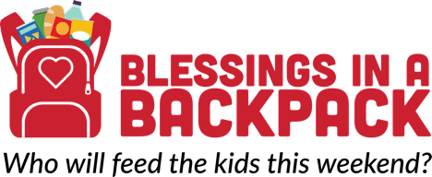

Corporate e-mail pitch sample

Hello. Reading about (company’s) impressive philanthropy investments prompted this outreach with hopes of partnering to prevent childhood hunger in (city).

Blessings in a Backpack (Blessings) is a 501c3 nonprofit organization dedicated to ensuring that children who face food insecurity have weekend nutrition. Our organization is the only one on a national scale that has volunteers who procure, pack and distribute food to children in elementary schools. To address the more than 13 million children in America who face hunger on a regular basis, Blessings provides a bag of nutritious food each Friday during the school year to over 87,000 children in 45 states and Washington, D.C. While children have access to their school’s free and reduced meals program during the school week, many suffer with hunger during the weekend. We are able to feed in a child in our program during the entire school year for $115.

We pride ourselves on efficiency and effectiveness to support kids who have struggled with accessing food on weekends. In the words of a child served by our program, “Your food donations have positively changed our school. We love our bags so much. You don’t know how grateful we are.”

There are more (#) children in (name) County – (#) percent of the population - that suffer with hunger on a regular basis. Blessings seeks to sustain and expand the number of children served in our community. Given alignment with (company’s) corporate social responsibility mission that includes childhood hunger prevention, we are inquiring about the possibility of a partnership that could be mutually beneficial. Blessings serves (#) children here in our community where your company has a business presence.

I would appreciate your thoughts on whether partnering with our organization may be possible. Thanks in advance for your consideration of this inquiry. I can be reached at ###-###-####. Hopefully, we can connect and collaborate so that when the school week ends, more hunger-free weekends can begin!!

Best regards.

Name

