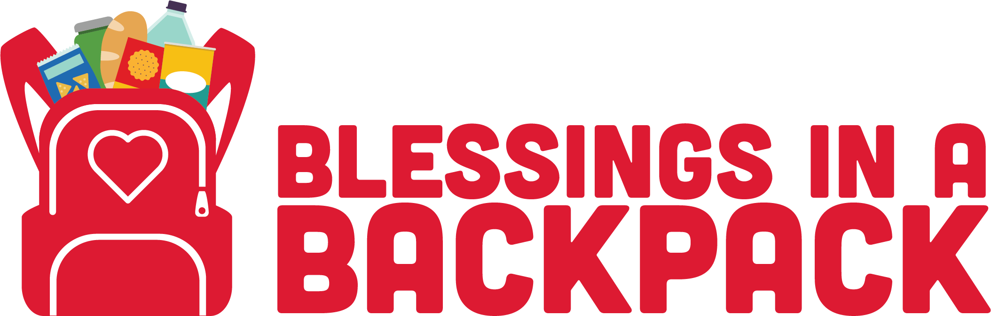

“As a parent working hard to provide for my family, Blessings in a Backpack is more than just filling a belly – to some it's joy, to some it's peace, to some I'm sure it's taking care of their family...for me, Blessings in a Backpack is all of the above.” – Ashley, Louisville, Kentucky, Parent of a child in the Blessings in a Backpack Program

"I heard about Blessings in a Backpack through my church. I grew up in poverty and organizations like yours helped my mother in feeding me and my three brothers. Without this type of support, I'm not sure I'd be where I am today."
- Christina, Boca Raton, Florida, Blessings in a Backpack Donor

“It was a few days before spring break – teachers were very excited! But sadly, at my school most of the students do not get excited about too many days off! I was asking my student if she had any exciting plans for spring break. She said no, just take care of her brother and sister. She, like all of the other student knew, that if they wanted a snack – they could ask me. A few minutes later she quietly walked up to me and whispered – she doesn’t like to take long breaks from school because they usually don’t have enough food to eat and her younger brother and sister get fussy.” - Diana, Jacksonville, Florida, Teacher in a school with the Blessings in a Backpack Program

“ I think every kid at Engelhard should get 2 Blessings in a Backpack. We need to share at home with our family. My baby sister don’t get Blessings in a Backpack. I share with her and get less food. Kids should get to be full.” - Darnell, Louisville, Kentucky, Student in the Blessings in a Backpack Program

“The Blessings in a Backpack program is great because it has taught my boys that being a blessing to someone is a good thing, no matter how big or small the blessing is.”
- Latisha, Chicago, Illinois, Parent of children in the Blessings in a Backpack Program

