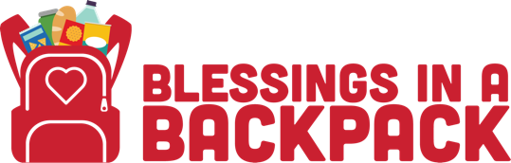

(Flyer Template)
Community Food Drive
We invite community members to participate in a local food drive

Location:
Date:
Time:
Items Needed:
- Individual cereal bowls/boxes
- Cereal/Granola bars
- Shelf stable yogurt or milk packages
- Fruit pouches or cups
- Juice boxes (100% juice only)
- Sunflower seeds
- Meat sticks (i.e., Jack Links, Slim Jim)
- Individual packaged crackers (i.e., Cheez Its, Goldfish Cheddar Crackers, Animal Crackers, Pretzels, Popcorn)
- Raisins or craisin packets
- Fresh produce - apple, orange, mandarin orange
- Chef Boyardee (or generic brand) ready to eat pasta bowls (pop-top lids required)
- Ready to eat soup (pop-top lids required)

For more information:

Name:

Phone Number:

Email:

